Thy Word is a lamp to my feet and a light to my path.
I have sworn an oath and confirmed it,
to observe Thy righteous ordinances.
I am sorely afflicted;
give me Life, O Lord, according to Thy Word!

Psalm 119:105-107
Click on this word. A box should appear. This box is for the particulars of the congregation, time, address, pastor, etc.
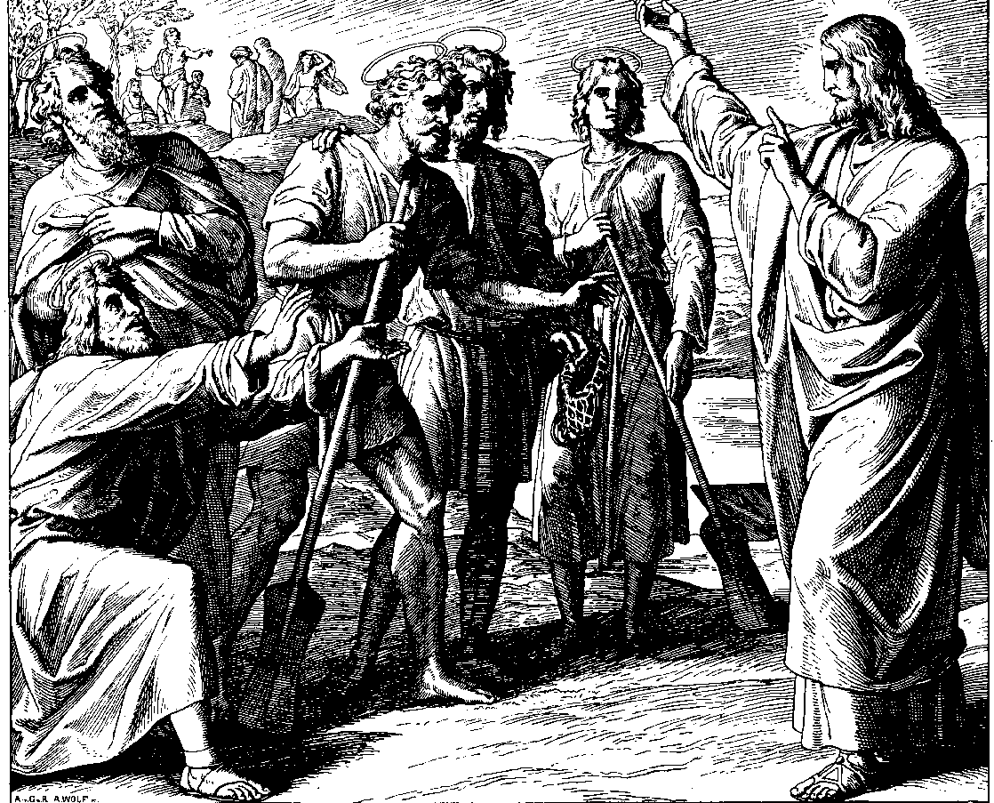
To deny one’s self is, moreover, to renounce one’s own honor. But our highest honor ought to be connected with the highest good alone, and God is that highest good. If we seek our own glory we cannot seek God’s glory, as the Saviour said to the Pharisees, “How can ye believe, which receive honor one of another” (John v. 44)? Behold the example of Christ, and follow that; He frequently declares of Himself that He seeks not His own glory (John viii. 50), that He receives not honor of men (John v. 41), that He is lowly in heart (Matt. xi. 29). Thou receivest all from God, render in return all to Him. All the streams of blessing we enjoy flow from the fountain of divine goodness; hence all the good we have ought to be borne back again into that ocean of divine love. The sunflower is said to be always turning itself toward the sun from which it draws its life and nourishment. So do thou, with all thy gifts and all thy honor, keep always turning thyself to God, and give no honor to thyself. … So if thou gloriest in thy good works as the product of thine own honor and pride, and givest not the glory of them to God alone, He will cast thee away from His presence forever.
Sacred Meditations
by Johann Gerhard
pages 177-178
Published by Repristination Press in 1998.
Used with permission.
3rd Sunday after the Epiphany

27 January Anno Domini 2002

Repent, for the Kingdom of Heaven is at hand.

Matthew 4:17
Philip and Nathaniel Called by Julius Schnoor von Carolsfeld.
Permission to use this image is limited to personal and congregational use.
Courtesy of Wisconsin Evangelical Lutheran Synod - the World Mission Collection.

Scripture text is based on Revised Standard Version © 1946, 1952, 1971 Division of Education and Ministry of the National Council of the Churches of Christ in the United States of America.
All Rights Reserved.

This bulletin cover made available by www.scholia.net and is provided without cost.

Thy Word is a lamp to my feet and a light to my path.
I have sworn an oath and confirmed it,
to observe Thy righteous ordinances.
I am sorely afflicted;
give me Life, O Lord, according to Thy Word!

Psalm 119:105-107
To deny one’s self is, moreover, to renounce one’s own honor. But our highest honor ought to be connected with the highest good alone, and God is that highest good. If we seek our own glory we cannot seek God’s glory, as the Saviour said to the Pharisees, “How can ye believe, which receive honor one of another” (John v. 44)? Behold the example of Christ, and follow that; He frequently declares of Himself that He seeks not His own glory (John viii. 50), that He receives not honor of men (John v. 41), that He is lowly in heart (Matt. xi. 29). Thou receivest all from God, render in return all to Him. All the streams of blessing we enjoy flow from the fountain of divine goodness; hence all the good we have ought to be borne back again into that ocean of divine love. The sunflower is said to be always turning itself toward the sun from which it draws its life and nourishment. So do thou, with all thy gifts and all thy honor, keep always turning thyself to God, and give no honor to thyself. … So if thou gloriest in thy good works as the product of thine own honor and pride, and givest not the glory of them to God alone, He will cast thee away from His presence forever.
Sacred Meditations
by Johann Gerhard
pages 177-178
Published by Repristination Press in 1998.
Used with permission.
To place the graphic on this page:
Click on the graphic on the previous page and copy it.
Come down to this page. Click on the open space above and a graphic box should appear. Paste the graphic.

Change this frame and the box above by clicking the body of the text, deleting this text (not the box) and adding your particulars.
3rd Sunday after the Epiphany

27 January Anno Domini 2002
Philip and Nathaniel Called by Julius Schnoor von Carolsfeld.
Permission to use this image is limited to personal and congregational use.
Courtesy of Wisconsin Evangelical Lutheran Synod - the World Mission Collection.

Scripture text is based on Revised Standard Version © 1946, 1952, 1971 Division of Education and Ministry of the National Council of the Churches of Christ in the United States of America.
All Rights Reserved.

This bulletin cover made available by www.scholia.net and is provided without cost.

Repent, for the Kingdom of Heaven is at hand ( Matthew 4:17).

